Research Article

Comparative Analysis of Machine Learning Models for Detection of Fake News: A Case Study of Covid-19

Abisola Olayiwola1, Ajibola Oyedeji1, Oluwakemi Omoyeni1, Oluwafemi Ayemimowa1, Mubarak Olaoluwa2

1 Department of Computer Engineering, Olabisi Onabanjo University, Ago-Iwoye, Nigeria

2 Telecom Physique Strasbourg, University of Strasbourg, France

|  |  |  |
| --- | --- | --- |
| Article Information |  | **ABSTRACT** |
| Received:  Revised:  Available online: | During and after the Covid-19 pandemic, people relied heavily on the internet for information because of its easy accessibility. However, the spread of fake information through this medium has been fast-growing, especially during and after the pandemic. It is therefore imperative to design and develop systems that can filter out fake and untrue news from social media platforms. This solution can be provided utilizing the power of artificial intelligence and machine learning methods. This study, therefore, aims to evaluate the performance of 5 machine learning models used in detecting Covid-19 fake news. The models were trained using the Covid-19 dataset gathered online. The dataset contains 7,262 real news and 9,727 fake news, totalling 16,989 news altogether. 80% of this dataset was used for training the models while 20% was used for testing them. The support vector machine (SVM) with 96%, 96%, 97% and 96% for the accuracy, precision, recall and F1-score respectively was the best classifier for detecting Covid-19 fake news and has shown a better performance than the other algorithms. |
| Keywords |
| Covid-19, Fake news detection, Classification, Machine Learning, Accuracy |
| Correspondence |
| Phone: +234(905)6728637  E-mail: [oyedeji.ajibola@oouagoiwoye.edu.ng](mailto:oyedeji.ajibola@oouagoiwoye.edu.ng) |

# INTRODUCTION

There is an increasing amount of information generated due to the exponential deployment of various technologies and social medium platforms. This phenomenon has also come with a risk of dissemination and communication of false, incorrect or misleading information [1]. During the Covid-19 pandemic when reliable information is vital for the health and safety of the populace, fake news began spreading faster than the facts due to the rapid development and proliferation of technology in online communication which caused intellectual confusion and placed people’s lives at risk. Amid the COVID-19 pandemic, individuals are exposed to this potentially harmful news without a means of verifying its authenticity.

Thus, there is a requirement to curtail the reach of such misinformation on the internet. This resulted in the removal of over 18 million coronavirus-related misinformation on Facebook and Instagram [2]. There is therefore a need for the development of technologies for the detection of false news [3].

Machine Learning (ML) enables systems to identify patterns from past data using some algorithms to build adequate solutions without being explicitly programmed. It is generally classified into 3 categories namely Supervised Learning (SL), Unsupervised Learning and Reinforcement Learning [4]. In SL, the system learns for input/output pairs. Classification is a type of SL that aims at predicting the target label of unseen data from previous data and can be binary or multiclass. In binary classification, the machine learning algorithms are trained to learn a set of rules to distinguish between two possible classes: True or False. A good example of binary classification is fake news detection while handwritten character recognition best describes a multiclass classification [5].

Various studies and research have been carried out on the detection of fake news including [6] which employed 4 text feature extraction techniques and 10 ML and deep learning methods for the detection. The accuracy of the methods tested ranged from 0.81 to 1.00. A study in [7] developed different ML ensemble models such as voting, bagging and boosting classifiers for 4 real-life datasets. The developed ensemble models performed better than the base learners used for comparison. A study in [8] curated a set of data with 10,700 social media stories containing real and fake news on the coronavirus. Different ML models were used for a binary classification task and the best performance of 0.93 F1-score was achieved with SVM [8].

Using ensemble ML models, better accuracy was achieved on the LIAR dataset [9]. The ensemble models achieved precision and recall of about 70% as against weak learners with about 39%. A multi-web platform voting framework was developed [10]. Upon performance evaluation, it was observed that the model was a good classifier as it correctly identified about 98% of the COVID misinformation [10].

A detection system using particle swarm optimization, the genetic algorithm, and the salp swarm algorithm was the subject of the study [11]. The genetic algorithm model achieved an accuracy of 75.4% while reducing the number of features. [11]. A comparative analysis of fake news classification ML models used on 3 datasets was presented [12]. The SVM classifier model had the best correct predictions with 0.61, 0.97 and 0.96 on the Liar, Fake Job Posting and Fake News datasets respectively [12]. An automated false news detection system for COVID-19 using 5 ML and deep learning (DL) algorithms was evaluated [13]. The DL models utilized the bidirectional encoder representations from transformers (BERT). BERT had an accuracy of 0.988 as a pre-trained classifier and 0.991 with deep learning models [13].

Most of the research studies on the detection of fake news are aimed towards the English language, which is why the study in [14] focused on detecting fake news in Hindi. Detecting fake news in languages with little research resources such as Hindi was carried out using a stack of pre-trained transformer models. The study reveals that the use of transfer learning from XLM-RoBERTa, mBERT and ELECTRA was able to achieve increased efficiency of fake news detection in Hindi [14]. The study of [15] presents a technique for detecting fake news using multimodal EFND. A Multilayer Perceptron was implemented and the results of the study showed that for the PolitiFact and GossipCop datasets, the EFND achieved an accuracy of 0.988% and 0.990%, respectively [15].

This project aims to design an efficient Covid-19 fake news detection and classification system using ML algorithms and also focuses on the comparative analysis of the performance of ML models in detecting and classifying Covid-19 fake news. The classification models employed in this project are Decision Tree (DT), Random Forest (RF), Support Vector Machine (SVM), Logistic Regression (LR) and k-nearest neighbour (KNN). The developed systems can be implemented and incorporated into online social media networks and news outlets for filtering out fake news from available information.

# MATERIALS AND METHODS

***Covid-19 News Dataset***

Data collection involves the gathering and measuring of information from countless different sources. The dataset used in this work consists of news articles labelled as fake or real and are gathered from online sources. The dataset contains 7,262 real news and 9,727 fake news, totalling 16,989 news altogether. In Table 1, each news article in the dataset has a title, outcome and label while Figure 1 shows the normalized frequency of the target labels. The real news is labelled as 0 while the fake news is labelled as 1.

Table 1. Sample of Dataset from GitHub Repository

|  |  |  |
| --- | --- | --- |
| **Text** | **Outcome** | **Label** |
| 'Eerily quiet': How California's early action against COVID-19 delayed the surge at hospitals | real | 0 |
| Store owners say some still not following 'physical distancing' rules | real | 0 |
| What you need to know about P.E.I.'s new COVID-19 testing and cough and fever clinics | real | 0 |
| WHO warns against consuming cabbage to prevent COVID-19 | fake | 1 |
| A picture shows hydroxychloroquine is being sold on public trains in Rio de Janeiro | fake | 1 |
| There is evidence that chlorine dioxide cures COVID-19 | fake | 1 |

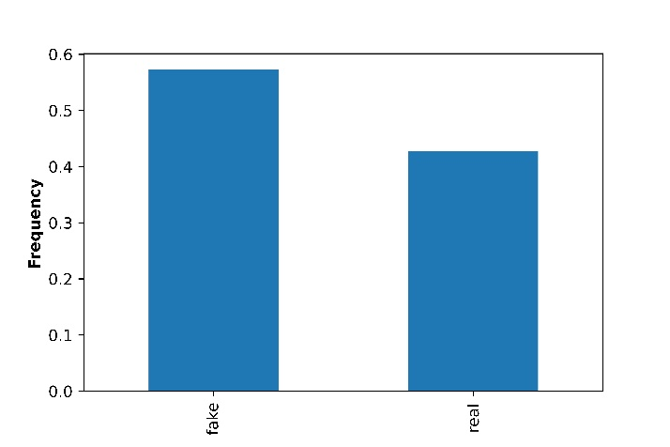

Figure 1. Normalized Frequency Count of the Outcome Labels

***Feature Extraction***

The dataset gathered was in raw form and cannot be used for analysis, hence the need for data preprocessing. Data preprocessing involves converting the raw data into a clean dataset. Stop-word removal, tokenization, lower casing, sentence segmentation, and punctuation removal were data preprocessing steps taken to remove unwanted information from the data and consequently reduce the dataset's original size. These were done using the NLTK (The Natural Language Toolkit) package. Furthermore, the dataset was converted from texts to numerical values because the models can only understand numerical data, using the TF-IDF Vectorizer.

To train the models, the dataset was randomly split into the training and testing dataset in a ratio of 4-to-1. The algorithms learned using the training dataset and evaluated with the test dataset to confirm that the models had not overfitted or memorized the train data.

***Model Training and Building***

The models used for classification are LR, DT, RF, SVM and KNN. To optimize the models and avoid overfitting during the model training, k-fold cross-validation and hyperparameter tuning were implemented using the GridSearch cross-validation (CV) method from the Scikit-Learn Python Library.

*Logistic Regression*

The LR model is a supervised learning model used for classification. by estimating the probability of the occurrence of an event, such as the news being fake or not. The logistic function is given as;

$logit p= \frac{1}{1+e^{-p}}$ (1)

The hyperparameters selected for the LR model after CV are max_iter = 100, C = 1.8, multi_class = multinomial.

*Decision Tree Classifier*

A DT is a flowchart-like tree structure in which an internal node represents a feature, a branch is a decision rule and the leaf nodes represent the decision outcomes. The model partitions the tree recursively based on the attribute values to classify the output label. Entropy measure is used to identify the root node of the DT. Entropy is defined in Equation 2.

$$Entropy (D)= \sum_{i=1}^{n}{-p_{i}\log_{2}{{(p}_{i})}} (2)$$

Where D is the data split, n is the number of decision classes, and pi is the proportion of records under the decision class i. The maximum number of splits in the DT designed is 200.

*Random Forest Classifier*

This is an ensemble learning algorithm for classification and regression. The RF method operates by combining several decision trees during the training phase using the bagging or bootstrap aggregation method by creating a different training subset from the training data with replacement. A DT is constructed for each data sample and a prediction value is obtained for each DT. The Gini coefficient method is used for splitting nodes.

$$Gini \left(D\right)=1- \sum_{i=1}^{n}{{p_{i}}^{2}} (3)$$

The final classification decision is made by taking a majority vote on all predictions obtained from the DTs. A maximum depth of 250 and 50 DTs was used for the RF model.

*Support Vector Machine*

The SVM is a supervised learning model used for both classification and regression and is widely used in text classification. Each data point is plotted in n-dimensional space with n being the number of features in the dataset. The model then performs classification by finding the optimal hyper-plane that differentiates the target labels. Kernel SVM is used for optimization as this is not linear data. A regularization parameter was set for 1.70 and the kernel coefficient for the radial basis function was set as scale.

*K-Nearest Neighbor*

The k-nearest neighbours (KNN) algorithm uses the distance between data points to make classifications. The class labels are selected based on the majority vote of the selected number of neighbors. The Euclidean distance is used to measure proximity as shown in Equation 4. The number of neighbors or the value of k is set to 14 and a weights parameter is set as distance.

$$Euclidean Distance= \sqrt{\sum_{i=1}^{n}{{(x_{i}- y_{i})}^{2}}} (4)$$

Where n is the length of the dataset, xi is the instances in the training set and yi is the instances in the test set.

# RESULTS AND DISCUSSION

This section presents the predicted results of each classification model and discusses each of them. There are two possible predicted classes: “Real” and “Fake”, and are represented by the label 0 and 1 respectively. The performance metrics used for the comparative analysis of the ML models are accuracy, precision, recall and F-1 score as defined in [7]. The confusion matrix for the models is presented in Table 2 below.

Table 2. Confusion Matrices of the 5 Machine Learning Models

|  |  |  |  |
| --- | --- | --- | --- |
| **Methods** | **Predicted Class** | | **Actual Class** |
| **0** | **1** |
| **LR** | 1348 | 104 | **0** |
| 80 | 1866 | **1** |
| **DT** | 1258 | 194 | **0** |
| 232 | 1714 | **1** |
| **RF** | 1308 | 144 | **0** |
| 104 | 1842 | **1** |
| **SVM** | 1370 | 82 | **0** |
| 61 | 1885 | **1** |
| **KNN** | 1321 | 113 | **0** |
| 114 | 1832 | **1** |

The test dataset contains 3,398 news which includes both real and fake ones. In Table 3, the LR model has 3,214 correct classifications and 184 incorrect classifications while SVM has 3,255 correct classifications and 143 incorrect ones. RF classified 3,150 news correctly and 248 news incorrectly while DT classified 2,972 news correctly and 426 news incorrectly. KNN got 3153 predictions correctly and 245 wrong. Hence, the SVM classification model has the highest number of correct predictions and DT has the least. SVM has the best performance followed by LR while the decision tree had the least performance.

Table 3. Classification Report of the Machine Learning Models

|  |  |  |
| --- | --- | --- |
| **Methods** | **Correctly Classified** | **Incorrectly Classified** |
| **LR** | 3214 | 184 |
| **DT** | 2972 | 426 |
| **RF** | 3150 | 248 |
| **SVM** | 3255 | 143 |
| **KNN** | 3153 | 245 |

The four parameters used to evaluate the models taking the Fake class as the positive class and the calculation results are shown in Table 4 below.

Table 4. Evaluation Results of the Classification Models

|  |  |  |  |  |
| --- | --- | --- | --- | --- |
| **Methods** | **Accuracy** | **Precision** | **Recall** | **F1 Score** |
| **LR** | 0.95 | 0.95 | 0.96 | 0.95 |
| **DT** | 0.87 | 0.90 | 0.88 | 0.89 |
| **RF** | 0.93 | 0.93 | 0.95 | 0.94 |
| **SVM** | 0.96 | 0.96 | 0.97 | 0.96 |
| **KNN** | 0.93 | 0.93 | 0.94 | 0.94 |

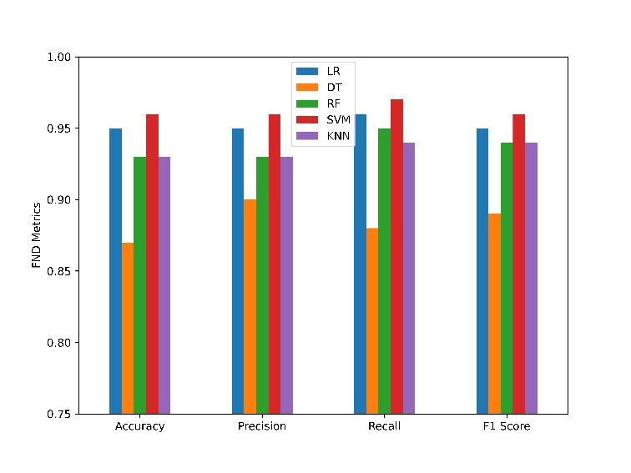

Figure 2. Performance of Classification Models

From the results in Table 4 and Figure 2, the SVM with 96%, 96%, 97% and 96% for the accuracy, precision, recall and F1-score respectively was the best classifier followed by the LR with values of 95%, 95%, 96% and 95% respectively. RF with 93%, 93%, 95% and 94% respectively and KNN having 93%, 93%, 94% and 94% respectively were the third and fourth most performing models with the DT achieving the lowest and being the least preferred classifier with 87%, 90%, 88% and 89% respectively. Therefore, SVM had the best performance and is recommended for detecting fake news while DT is least recommended.

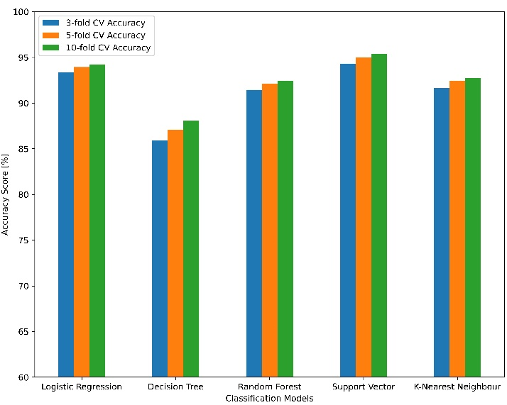

Figure 3. k-fold Cross Validation Accuracy

The results of the K-fold cross-validation across the five (5) models are shown in Figure 3 above. The graph shows results for the 3-fold, 5-fold and 10-fold cross-validations. The SVM for classification consistently had higher accuracy results than other models followed by LR, RF and KNN while DT had the worst classification accuracy.

The support vector machine and logistic regression models have unsurprisingly had the best performance. The SVM is optimized for use in text classification and handwriting classification on both linear and non-linear data. SVMs are also very effective in finding complex relationships in the data and often produce more accurate predictions than other models as evidenced throughout the results. Decision trees suffer badly in a high-dimensional feature space and this has been reflected in the DT having the worst values in all the performance metrics used.

# CONCLUSION

The comparative analysis of the performance of 5 machine learning classification models that are used to distinguish between real and fake Covid-19 news was carried out. The dataset contains 16,989 covid-19 news and was partitioned into training and testing to train and evaluate the models respectively. The evaluation results show that the Support Vector Machine has the highest positive predictions and the best performance in all evaluation scenarios. This study, therefore recommends SVM as the best classification algorithm for differentiating between real and fake Covid-19 news.

The study has not studied and considered the impact and effect of feature selection on the detection of covid-19 fake news. Further studies will be encouraged to implement feature selection and in addition, the best-performing model can be deployed to a web application for real-time detection and filtering of covid-19 fake news.

REFERENCES

[1] U. Sharma, S. Saran, and S. M. Patil, “Fake News Detection using Machine Learning Algorithms,” *Int. J. Eng. Res. Technol.*, vol. 9, no. 3, pp. 509–518, 2021.

[2] R. Gilmore, “Fake news on Facebook: 18 million posts containing COVID-19 misinformation removed,” *Global News.*, 2021. https://globalnews.ca/news/7876321/covid-19-misinformation-social-media-facebook-instagram/tle (accessed Feb. 13, 2023).

[3] R. Varma, Y. Verma, P. Vijayvargiya, and P. P. Churi, “A systematic survey on deep learning and machine learning approaches of fake news detection in the pre- and post-COVID-19 pandemic,” *Int. J. Intell. Comput. Cybern.*, vol. 14, no. 4, pp. 617–646, 2021, doi: 10.1108/IJICC-04-2021-0069.

[4] A. O. Oyedeji, A. M. Salami, O. Folorunsho, and O. R. Abolade, “Analysis and Prediction of Student Academic Performance Using Machine Learning,” *JITCE (Journal Inf. Technol. Comput. Eng.*, vol. 4, no. 01, pp. 10–15, 2020, doi: 10.25077/jitce.4.01.10-15.2020.

[5] J. Y. Khan, M. T. I. Khondaker, S. Afroz, G. Uddin, and A. Iqbal, “A benchmark study of machine learning models for online fake news detection,” *Mach. Learn. with Appl.*, vol. 4, p. 100032, 2021, doi: 10.1016/j.mlwa.2021.100032.

[6] A. Abdulrahman and M. Baykaya, “Fake News Detection Using Machine Learning and Deep Learning Algorithms,” in *Third International Conference on Advanced Science and Engineering (ICOASE2020)*, 2020, pp. 18–23.

[7] I. Ahmad, M. Yousaf, S. Yousaf, and M. O. Ahmad, “Fake News Detection Using Machine Learning Ensemble Methods,” *Complexity*, vol. 2020, 2020, doi: 10.1155/2020/8885861.

[8] P. Patwa *et al.*, “Fighting an Infodemic: COVID-19 Fake News Dataset,” *Commun. Comput. Inf. Sci.*, vol. 1402 CCIS, pp. 21–29, 2021, doi: 10.1007/978-3-030-73696-5_3.

[9] L. Waikhom and R. S. Goswami, “Fake News Detection Using Machine Learning,” in *International Conference on Advancements in Computing & Management (ICACM-2019)*, 2019, pp. 680–685.

[10] D. Varshney and D. K. Vishwakarma, “An automated multi-web platform voting framework to predict misleading information proliferated during COVID-19 outbreak using ensemble method,” *Data Knowl. Eng.*, vol. 143, 2023, doi: 10.1016/j.datak.2022.102103.

[11] B. Al-Ahmad, A. M. Al-Zoubi, R. A. Khurma, and I. Aljarah, “An evolutionary fake news detection method for covid-19 pandemic information,” *Symmetry (Basel).*, vol. 13, no. 6, 2021, doi: 10.3390/sym13061091.

[12] D. Choudhury and T. Acharjee, “A novel approach to fake news detection in social networks using genetic algorithm applying machine learning classifiers,” *Multimed. Tools Appl.*, 2022, doi: 10.1007/s11042-022-12788-1.

[13] M. Taha, H. H. Zayed, M. Azer, and M. Gadallah, “Automated COVID-19 misinformation checking system using encoder representation with deep learning models,” *IAES Int. J. Artif. Intell.*, vol. 12, no. 1, pp. 488–495, 2023, doi: 10.11591/ijai.v12.i1.pp488-495.

[14] A. Praseed, J. Rodrigues, and P. S. Thilagam, “Hindi fake news detection using transformer ensembles,” *Eng. Appl. Artif. Intell.*, vol. 119, 2023, doi: 10.1016/j.engappai.2022.105731.

[15] M. I. Nadeem *et al.*, “EFND: A Semantic, Visual, and Socially Augmented Deep Framework for Extreme Fake News Detection,” *Sustain.*, vol. 15, no. 1, 2023, doi: 10.3390/su15010133.